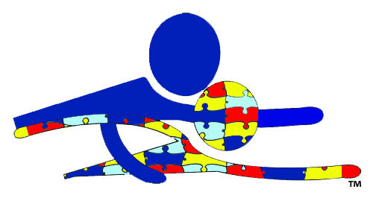

Swim Lesson Registration Form

Participant(s):
1. Name: __________________________________________________________________________________ DOB: _________________________________ M F

Please Select
Private Day
Semi-Private Time
Group
2. Name: __________________________________________________________________________________ DOB: _________________________________ M F
Parent or Guardian Contact Information:
Name(s): _____________________________________________________________________________________________ Relationship: _________________________________________
Address:__________________________________________________________________________ City: ___________________________________ St: _________ Zip: _________________
Home Phone: ______________________________________________ Cell: ____________________________________________ Work: ________________________________________
Email: ________________________________________________________________ How did you hear about us? __________________________________________________

Briefly describe the student’s current swimming abilities: _________________________________________________________________________
_________________________________________________________________________________________________________________________________________________
_________________________________________________________________________________________________________________________________________________
Does the student have a disability? Yes No Verbal Non-Verbal
If yes, please detail the disability and/or any special concerns we should be made aware of (fear of water, unpleasant experiences, etc.):
_________________________________________________________________________________________________________________________________________________
_________________________________________________________________________________________________________________________________________________
What motivates the student? _____________________________________________________________________________________________________________
Please circle the day(s) you would like to take lessons M T W TH Sat
What times are best? ________ ______ __________ __________ ___________
Desired Lesson Type: Private ∙ Semi ∙ Parent/Child

Signature: _____________________________________________________________________________________ Date: _______________________________________

For office use only
1. Day/Time:_______________ 2. . Private ∙ Semi ∙ Group + Babies 3. Pool Location: ____________________________ 4. . Start Date: _________________

